# Chapter 4

# Implementation

## 4.1 Description of Modules

## The Blood Bank Management System consist of 7 modules and all the modules that are present in this consist of similar operation that is adding, searching and updating These operation are used to manipulate the data in the database and based on the requirements the additional functionality like one stored procedure and trigger are implemented.

The modules present in the Blood Bank Management System are:-

* **Donor**
* **Acceptor**
* **Add Donor and Acceptor**
* **Search Donor and Acceptor**
* **Blood**

**4.1.1 Donor Module**

In Donor module consists of other modules which will be further used for adding new

donor entry with basic and important data and also searching a particular donor on bases of

donor id and donor name.

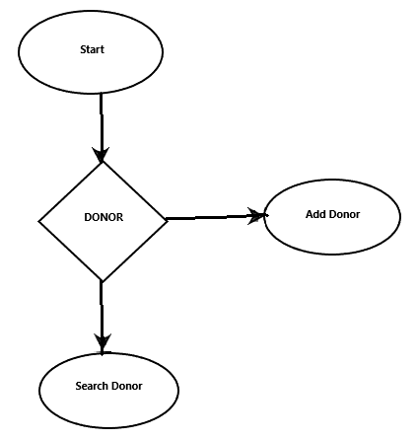

**Fig 4.1.1 Data flow diagram for Donor**

**4.1.2 Acceptor Module**

In Acceptor module consists of other modules which will be further used for adding

new Acceptor entry with basic and important data and also searching a particular

Acceptor on bases of Acceptor id and Acceptor name.

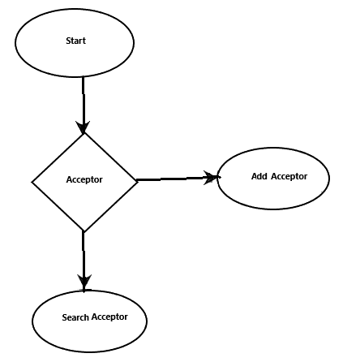

**Fig 4.1.2 Data flow diagram for Acceptor**

**4.1.3 Add Donor And Acceptor Module**

In this module we are provided with a form that consists of fields to fill correct details

of Donor/Acceptor . After the data is added and saved then this module access the

database of respective type , then the data is stored in the database

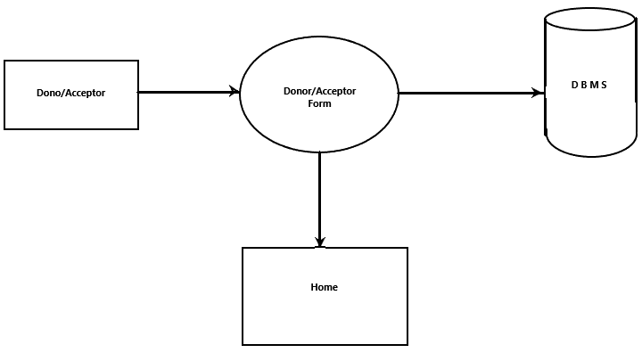

**Fig 4.1.2 Data flow diagram for Add Doctor And Acceptor**

**4.1.4 Search Donor And Acceptor Module**

This module is used after the addition of Donor/Acceptor data to the Database.

Here we can search a entry with Donor/Acceptor id or a name . The working of this module

is that when a search is done the data is sent to the database which consists of id or a name

of Donor/Acceptor and the matching entry is shown to the user.

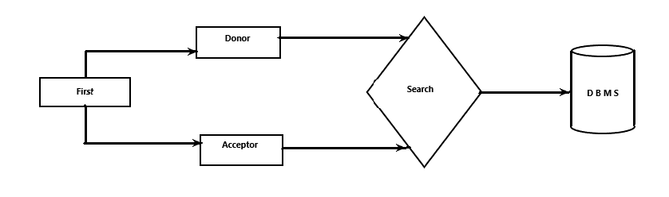

**Fig 4.1.4 Data flow diagram for Search Donor And Acceptor**

**4.1.5 Blood Module**

This module is used for viewing all the records available in the database. In other

words when user triggers this module the program access the database and retrieve all

information from database to program and the program shows the data to the user.

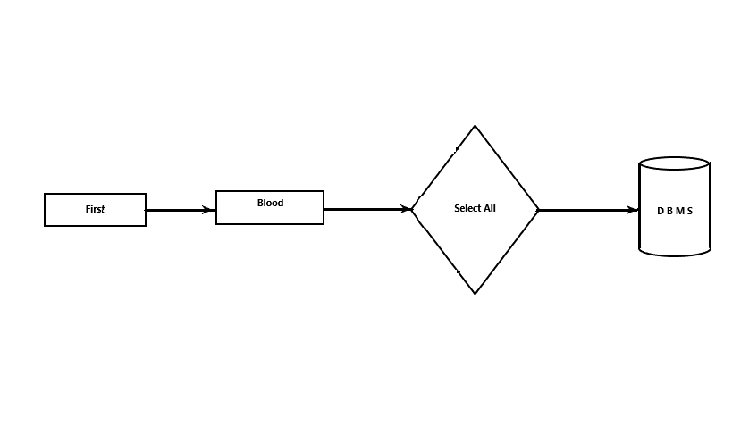

**Fig 4.1.5 Data flow diagram for Blood**